**“Pepper’s Cone” Display**

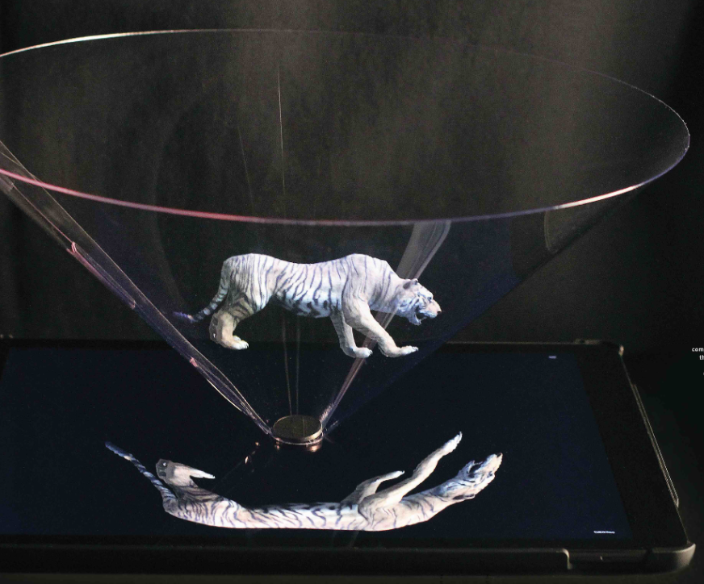

Michelle Garcia, Luna Khan, Chloe Sawatzki, Jennifer Senra Bruzon

University of Florida

CEN 3907c - CpE Design 1

Dr. Blanchard

02/19/2025

**TABLE OF CONTENTS**

**Introduction 3**

Purpose / Need 3

Domain & Prior Art 3

Impact & Risk Assessment 3

**Statement of Work 4**

Technical Specifications 4

Project Timeline and Team Responsibilities 4

**Deliverable Artifacts 5**

Hardware Deliverables 5

Software Deliverables 5

Documentation 5

Dissemination Plan 6

Maintenance Plan 6

**Mockups 6**

Interfaces 6

Systems 8

Networkings 9

StoryBoards 10

Draft Schematic 11

**Revisions** **11**

**References 11**

# Introduction

## Purpose / Need

Pepper’s Cone is an innovative visualization tool designed to display hologram-like images in an interactive and engaging way. Unlike traditional screens or projectors, Pepper’s Cone provides a three-dimensional illusion, enhancing spatial learning and data representation. The shift towards e-learning environments has highlighted the need for more engaging and interactive remote learning experiences. While video conferencing platforms have enabled remote education, they often lack the presence and engagement of in-person instruction. Our large-scale Pepper's Cone display project addresses this gap by creating a life-sized "holographic" representation of instructors in the classroom, combining the flexibility of remote teaching with the immersive quality of in-person instruction. This system goes beyond mere demonstration by providing a practical, scalable solution for hybrid learning environments.

## Domain & Prior Art

This project builds upon the principles of Pepper's Ghost, a theatrical illusion technique dating back to the 19th century. Notable implementations include Disney's Haunted Mansion [3] attraction and various stage productions. Recent academic work includes smaller-scale Pepper's Cone displays at the University of Florida. Commercial solutions like ARHT Media's holographic telepresence [1] exist but are typically cost-prohibitive for educational institutions. Our project differentiates itself through:

* Scalability to 72-inch display size
* Integration with common video conferencing platforms
* Open-source implementation
* Cost-effective design suitable for educational environments

## Impact & Risk Assessment

The project carries several significant impacts:

Cultural Impact:

* Enhances educational engagement through innovative technology
* Bridges the gap between remote and in-person learning experiences
* Contributes to the evolution of hybrid learning environments

Economic Impact:

* Provides a cost-effective alternative to commercial holographic solutions
* Potential for widespread adoption in educational institutions
* Reduces travel costs for guest lectures and remote teaching

Technical Impact:

* Advances large-scale implementation of Pepper's Ghost technique
* Contributes to open-source video processing solutions
* Establishes framework for future telepresence innovations

Ethical Considerations and Implications:

* Privacy concerns regarding video recording and storage of lectures
* Potential psychological impact on students adapting to holographic instruction
* Accessibility considerations for visually impaired students
* Equal access to technology across different educational institutions
* Responsibility to clearly communicate the limitations of the technology to users

Technical Risks and Limitations:

* Image quality degradation in highly lit environments
* Potential latency issues affecting real-time interaction
* Limited viewing angles requiring careful classroom setup
* Need for regular maintenance of the polymer film surface
* Possible eye strain from prolonged exposure to holographic displays

# Statement of Work

## Technical Specifications

Display Requirements:

* Minimum 4K resolution (3840 × 2160)
* Brightness: 500+ nits
* Maximum latency: 100ms
* Viewing angle: 120 degrees horizontal

Software Components:

1. Video Processing Framework
   * Primary: OpenCV for real-time video processing
   * Secondary: FFmpeg for video stream handling
   * Python/C++ implementation for optimal performance
2. Image Processing Requirements
   * Real-time perspective correction
   * Color and brightness adjustment
   * Background removal
   * Frame interpolation for smooth motion

Hardware Components:

* 72-inch LED display
* Custom-manufactured polymer film (for cone)
* Support structure with precise angle control
* Video capture and processing hardware

## Project Timeline and Team Responsibilities

Semester 1 (Core Features)

1. Research (Week 1)
   * Look at the GitHub and get it running (All Members)
   * Search for needed materials (All Members)
   * Read up on the project (All Members)
2. Software Development (Weeks 2-4)
   * Video processing pipeline implementation (All Members)
   * Open source code implementation on local machines (All Members)
   * Small scale code prototypes for image processing (All Members)
3. Small-scale Prototype (Weeks 5-9)
   * FPGA design and testing (Jennifer, Chloe)
   * Display calibration system (All Members)
   * Initial polymer film testing (Luna, Michelle)

Semester 2 (Scale-up and Refinement)

1. Large-scale Implementation (Weeks 1-8)
   * 72-inch display integration (Michelle, Chloe)
   * Polymer film manufacturing and installation (Luna, Jennifer)
   * Advanced image processing optimization (All members)
2. System Integration and Testing (Weeks 9-16)
   * Performance optimization (All members)
   * User testing and feedback integration (All members)
   * Documentation and deployment guides (All members)

# Deliverable Artifacts

## Hardware Deliverables

1. Large-scale Display Assembly
   * Complete 72-inch display system with mounting hardware
   * Custom-manufactured polymer film
   * Calibration and adjustment mechanisms
2. Control System
   * Display control circuits
   * Video processing hardware setup
   * Power management system

## Software Deliverables

1. Video Processing Software
   * Open-source repository with complete source code
   * Documentation and API specifications
   * Installation and configuration guides
   * Performance optimization guidelines
2. User Interface
   * Control panel for display settings
   * Calibration tools
   * Integration guides for video conferencing platforms

## Documentation

1. Technical Documentation
   * System architecture specifications
   * Hardware assembly instructions
   * Software deployment guides
   * Maintenance procedures
2. User Documentation
   * Operating instructions
   * Troubleshooting guides
   * Best practices for optimal usage

## Dissemination Plan

* All software will be released on GitHub
* Documentation will be available in PDF and web formats
* Assembly instructions will include detailed diagrams and videos
* Regular updates and maintenance through GitHub repository

## Maintenance Plan

* Modular design allowing component replacement
* Regular software updates through GitHub
* Documented cleaning and maintenance procedures
* Community support through GitHub issues

# Mockups

## Interfaces

1. Physical Interface: Mounting system on a 72-inch screen with a polymer cone

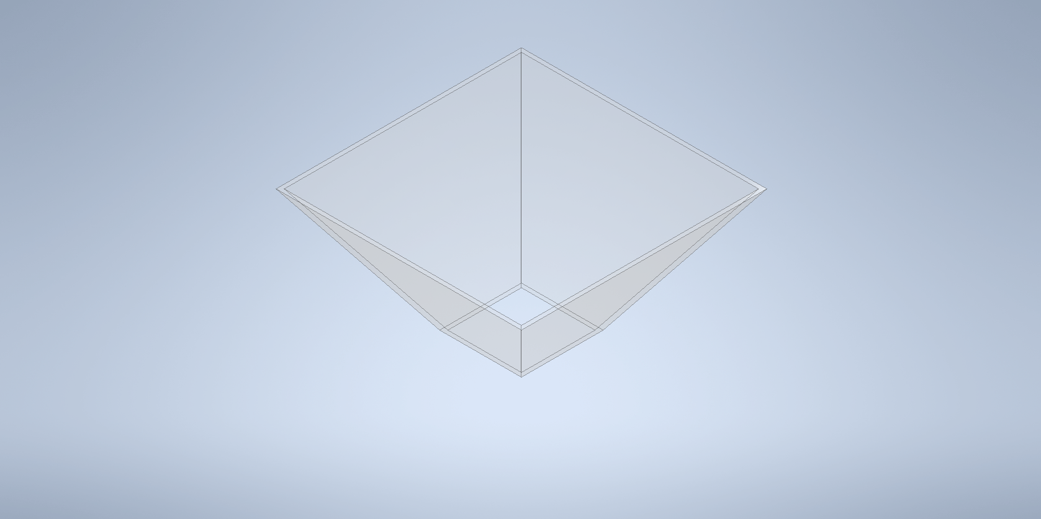

***Figure 1***: 3D model of the Pepper’s Cone.

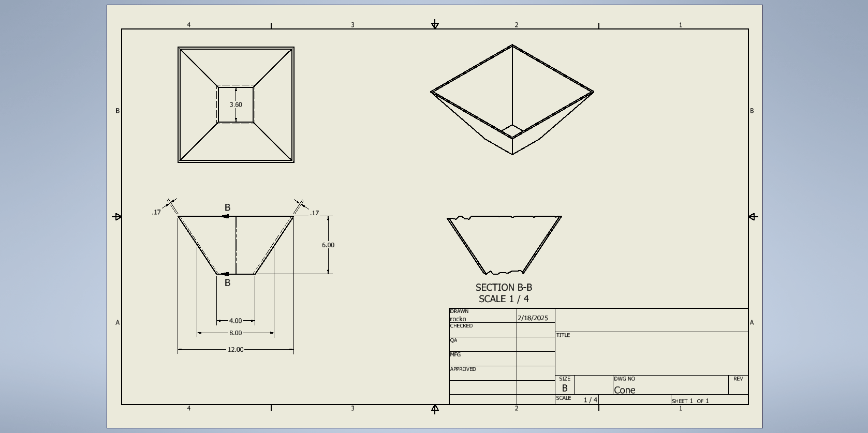

***Figure 2***: Sketch of Pepper’s Cone with all different views and dimensions. Dimensions are for our tablet version of the cone. It will be sized differently for a 75 inch TV.

1. Software Interface: User Interface

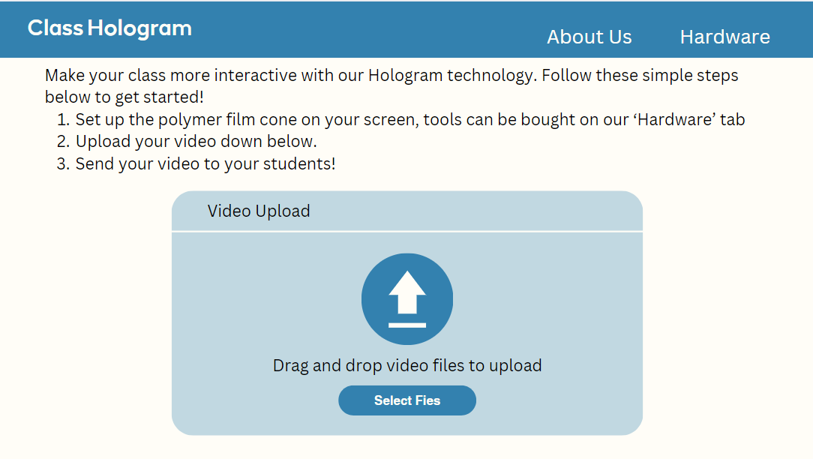

***Figure 3***: Initial setup, we will have the host upload their video. It will be processed through our image processing code and become available as a video to play in front of classes.

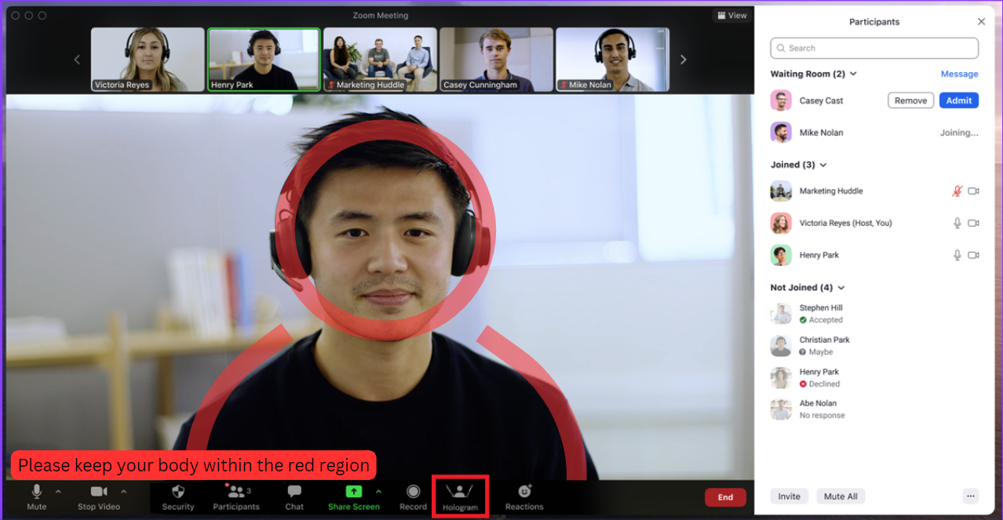

***Figure 4***: Pepper’s Cone ‘Hologram’ user interface on Zoom, icon highlighted in the diagram above in a red rectangle. Guidelines for the host are also displayed on the interface.

## 

## 

## Systems

1. Processing System
   * Video capture
   * Image processing
   * Output rendering
2. Control System
   * User interface
   * Calibration tools
   * System monitoring
3. Display System
   * 72-inch TV screen, horizontally mounted
   * Polymer film
   * Mounting structure, round base

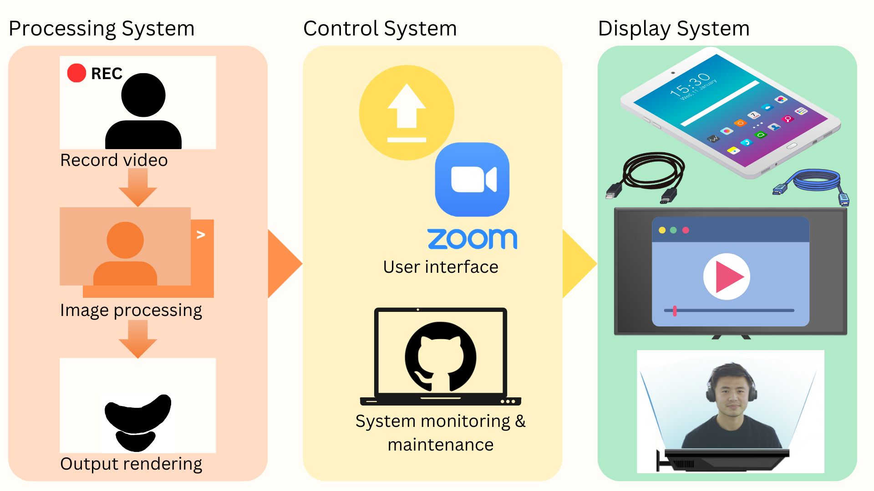

***Figure 6***: System Architecture Overview - The system consists of three main components: (1) The Processing System handles video capture, image processing, and output rendering; (2) The Control System manages the user interface through Zoom and system monitoring via GitHub; and (3) The Display System implements the final video output through the Pepper's Cone display configuration. The workflow progresses linearly from processing through control to final display.

## 

## Networkings

Does not apply since we will be using an HDMI cable.

## StoryBoards

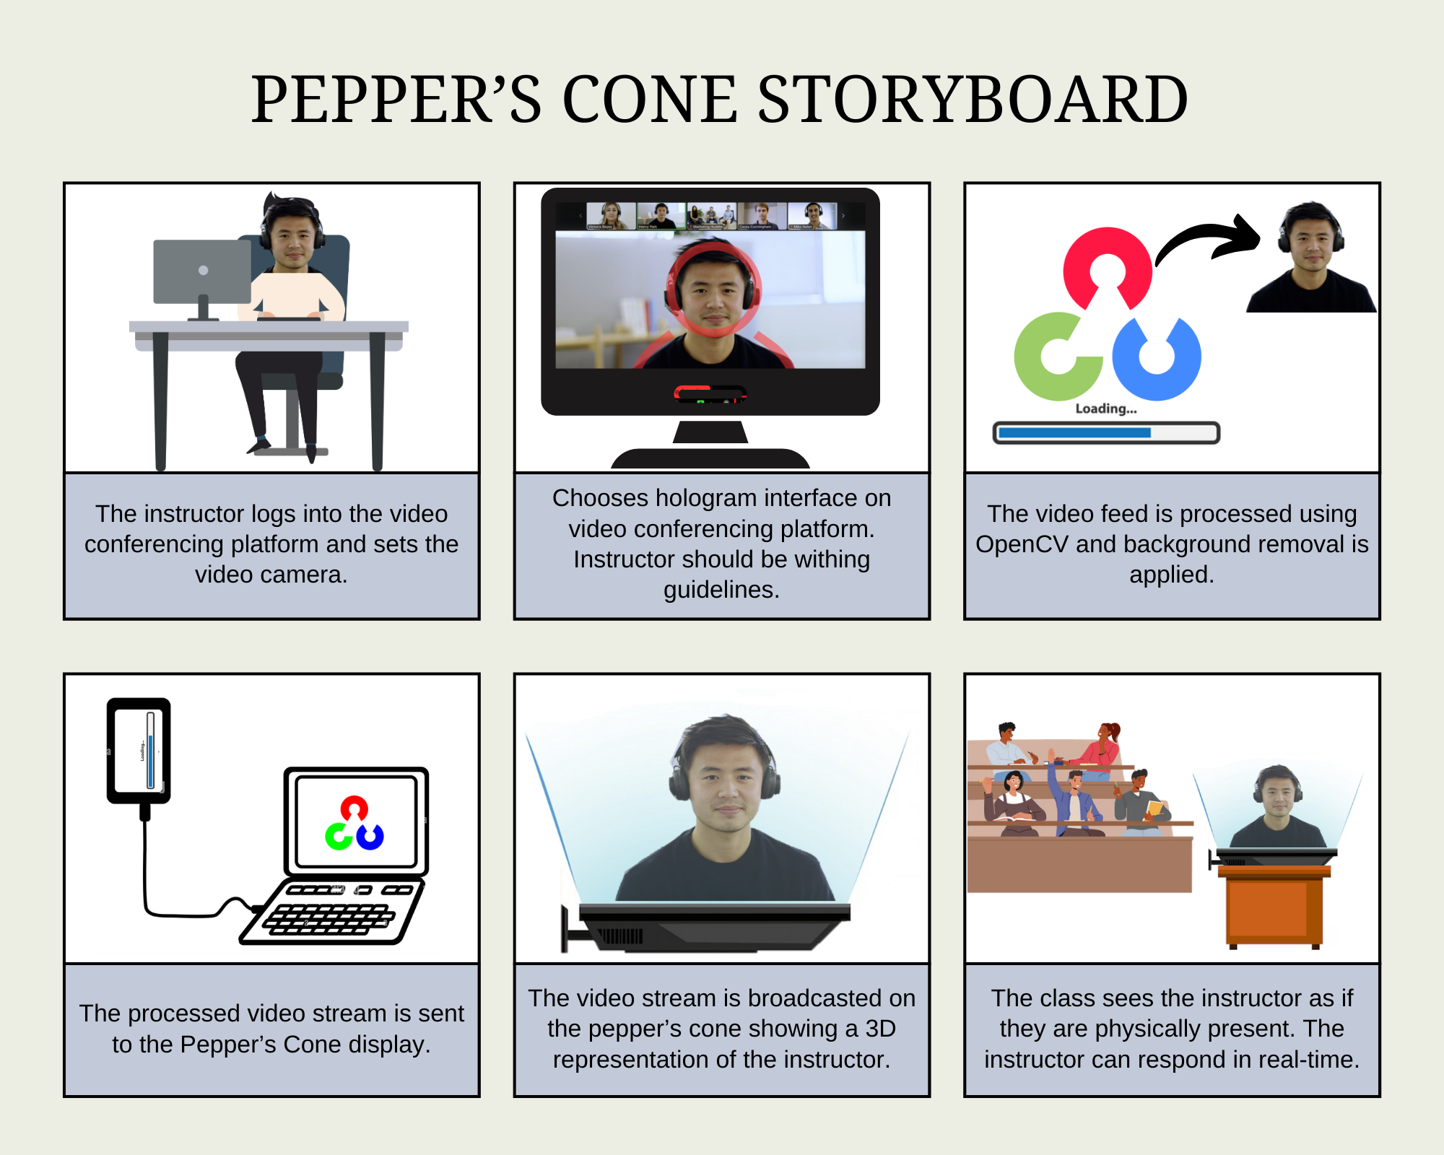

***Figure 5***: Visual storyboard outlining the key steps of how the Pepper’s Cone system will function.

## Draft Schematic

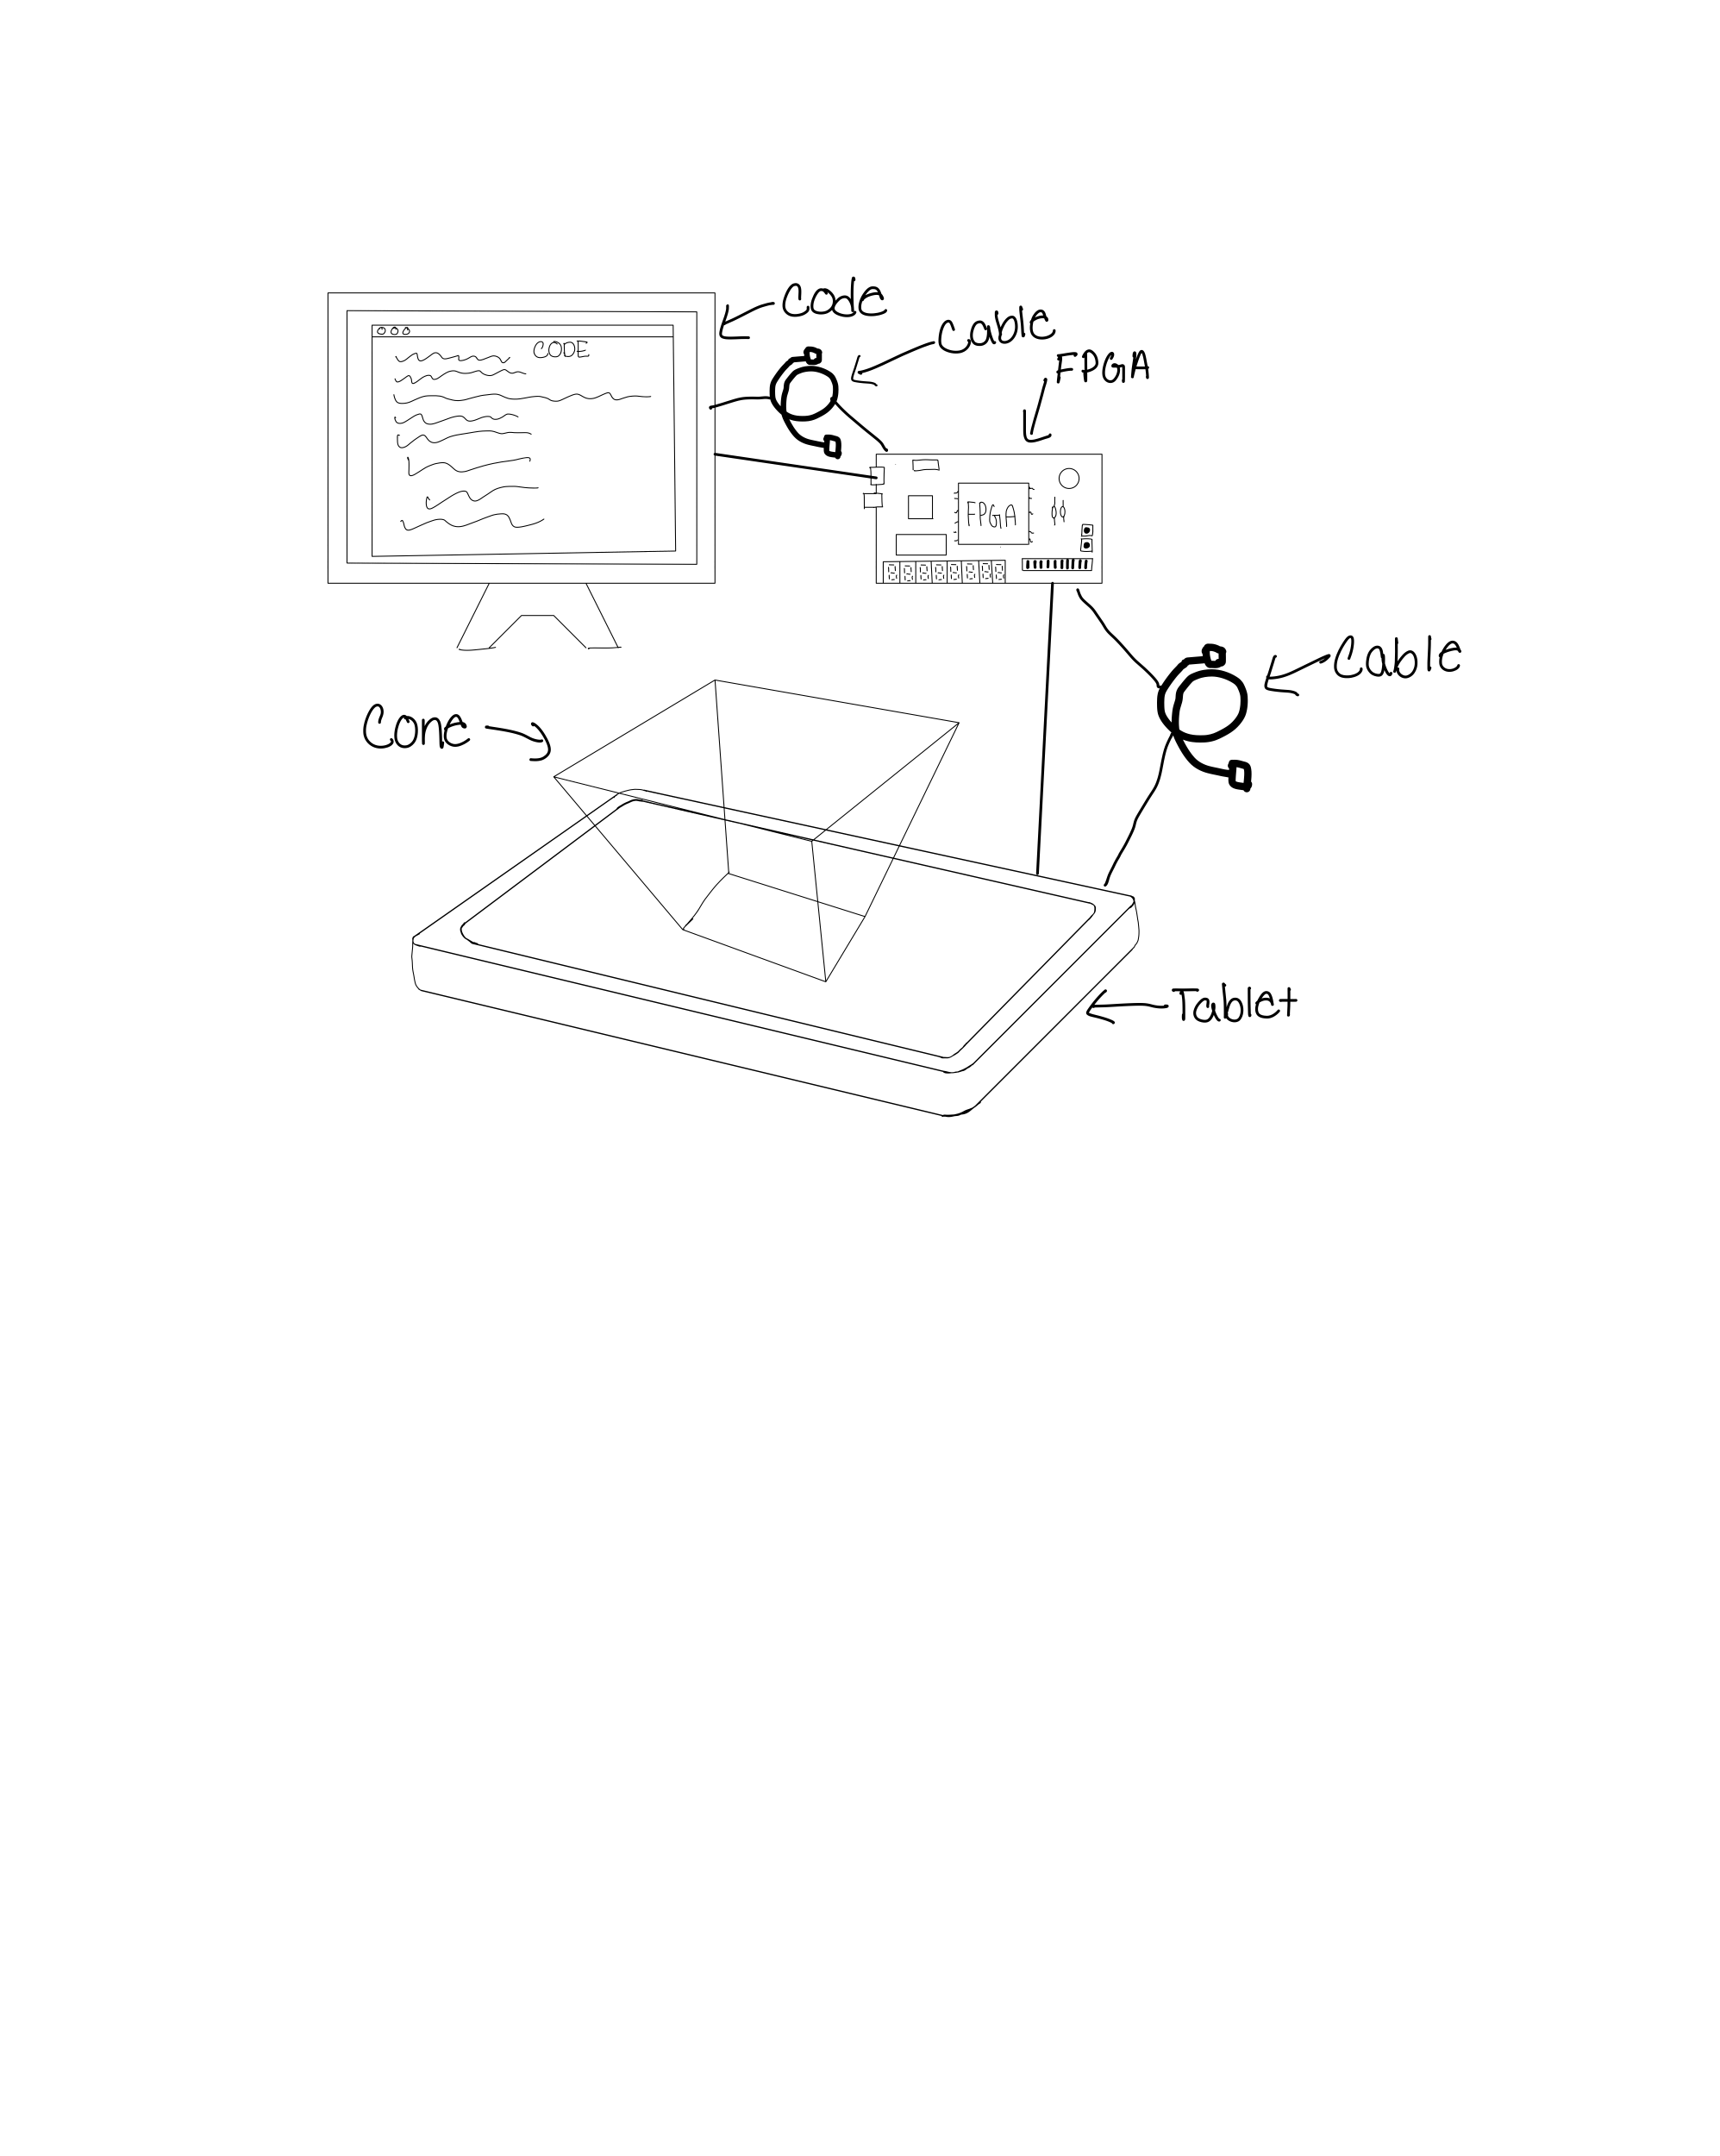

**Figure 6:** Code will help process the image to make the video function as a hologram. FPGA will handle large data from video processing. Tablet will display a processed version of the video that comes from computer/Code/FPGA. Cables will be used to connect the FPGA, Computer (with the code), and tablet. Cone will be placed on top of the tablet to create the hologram.

# Revisions

* No recommendations or revisions recommended.
* Reviewed as a team and decided to add to the references the GitHub Link.
* We reviewed and changed the project timeline to include the research aspect of this project.

# References

[1] ARHT Media Inc, “ARHT Media Launches CAPSULE - A New Touchscreen 4K Hologram Display,” *GlobeNewswire News Room*, May 26, 2022. https://www.globenewswire.com/news-release/2022/05/26/2451263/0/en/ARHT-Media-Launches-CAPSULE-A-New-Touchscreen-4K-Hologram-Display.html (accessed Feb. 19, 2025).

[2] C. Bavor, “Project Starline: Feel like you’re there, together,” Google, May 18, 2021. https://blog.google/technology/research/project-starline/

‌[3] Scott, “What Is The Pepper’s Ghost Effect Inside The Haunted Mansion,” The Main Street Mouse | Central Florida Theme Park News Source, Apr. 26, 2020. https://www.themainstreetmouse.com/2020/04/25/what-is-peppers-ghost/ (accessed Feb. 19, 2025).

[4] Roxanneluo, “Roxanneluo/pepper-S-cone-unity: Pepper’s cone,” GitHub, https://github.com/roxanneluo/Pepper-s-Cone-Unity (accessed Mar. 3, 2025).